zekiel's Temple Visions
generationword.com 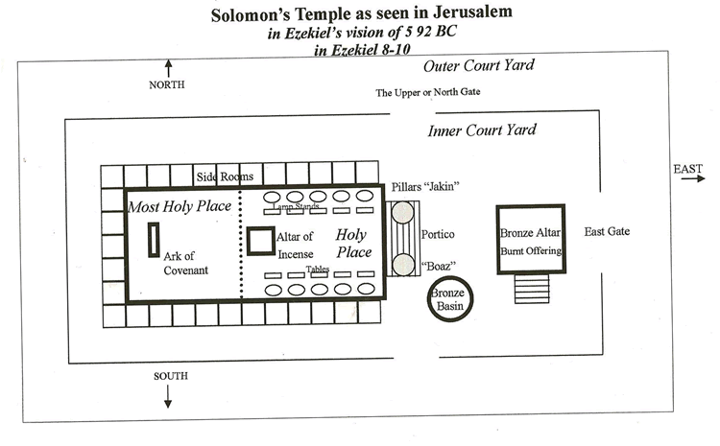
1. This is the temple that Solomon built. It was used in Ezekiel's day before the Babylonian captivity for idol worship.
2. The furniture still there from the original purpose was the bronze altar, the bronze basin, the ten lamp stands, the ten tables, the altar of incense and the ark of the covenant.
3. The two pillars out front of the holy place on the portico were called "Jakin" and "Boaz."
4. Only priest could enter the holy place and did most of the work in the inner court around the bronze altar and bronze basin.
5. Until the days of Ezekiel the presence of God dwelt in the Most Holy Place on the ark of the covenant.
6. Notice the three gates: the Upper (North) Gate, the main entry known as the East Gate, and the southern gate

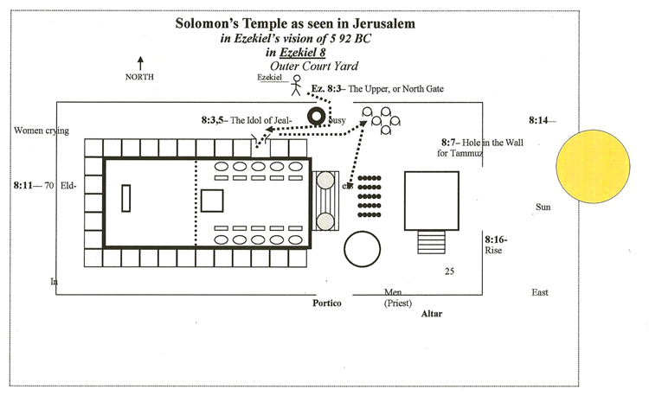
1. In Ezekiel 8:1, on Sept.17, 592 BC, Ezekiel was taken from Babylon to the Jerusalem temple in a vision while the captive elders watched him sit in a trance in his house.
2. Ezekiel is shown four things that God says shows why the people of Jerusalem must be judged.
3. ONE: When Ezekiel went into the temple through the North Gate he saw the idol of jealousy. Most likely an Asherah pole.
4. TWO: Then Ezekiel was told to dig through the wall and he saw images of idols drawn on the wall of the priestly rooms around the temple. There were 70 leaders of Israel worshipping there. Idolatry is a system of thinking that establishes a person's (or, society's) meaning to life, ethics, and plans for the future.
5. THREE: Ezekiel is then shown women crying for Tammuz. Tammuz was a false god who controlled the dry seasons and the seasons of rain. At the time of this vision it was the dry season (September) and the women were seeking Tammuz for the rain.
6. FOUR: The last line of defense for a nation is the priest who were to teach the people the Word of God. The Word was revealed to them in the written Law of Moses and the temple system of worship. The last hope for these people was that the priesthood would teach them the truth. But, the priests were standing between the altar and the portico of the temple with their backs to the temple worshipping the rising sun. Things do not look to hopeful for Jerusalem's future.

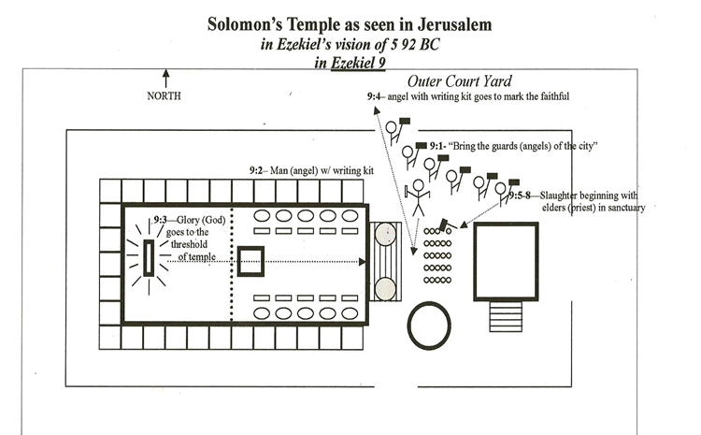

1. Ezekiel 9:1 God says, "Bring the guards of the city here, each with a weapon in his hand." Then six angels that had been guarding the city come in to receive orders to destroy the people.
2. Also, a man with a writing kit (a case to carry reed pens with an inkhorn attached) is told to put a mark (The Hebrew letter "taw", an "x") on the people who mourn for the wicked things done in the city.
3. The Lord leaves the ark of the covenant and moves to the door way (threshhold) of the temple to give instructions to the angels. (9:3)
4. The angel with the writing kit goes out into the city first to begin marking the faithful. These will be spared.
5. The angels with the "deadly weapons" (Hebrew "slaughter weapon" like a crushing device such as a battle ax, but not a sword) begin by slaughtering the 25 priest by the altar in front of the temple.

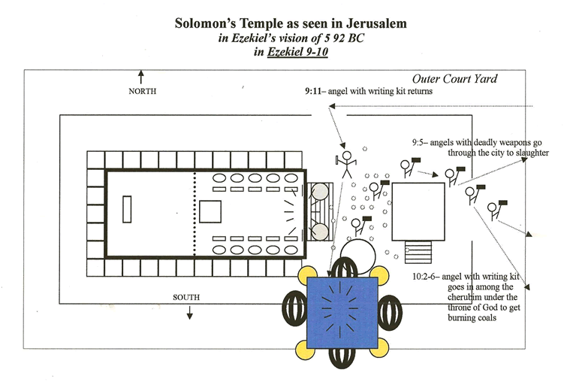

1. In 9:5 the destroying angels leave the temple for the city. They leave behind a temple court defiled with dead bodies of the priest.
2. Ezekiel pleads with God for mercy. But, the purpose of this vision is to convince Ezekiel that the people must be destroyed.
3. In 9:11 the angel with the writing kit returns and says, "I have done as you commanded."
4. This same scribe angel is told by God, who is at the door of the temple, to go to the cheribum under the throne/expanse on the south side of the temple and get burning coals.
5. This fire is the judgment that will be scattered over the city.
6. Ezekiel stresses that this vision of the glory of God in Jerusalem is the same image that he had seen with the captive exiles in Babylon by the Kebar River.
7. God is leaving Jerusalem, but is going with the exiles into Babylon.

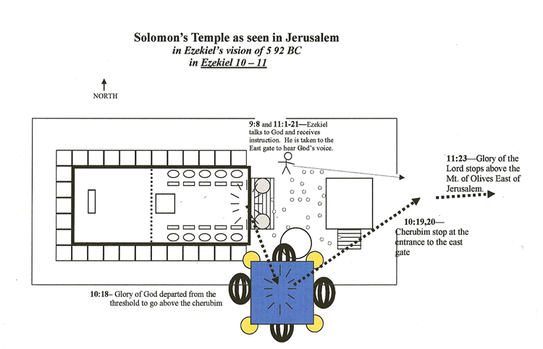
1. God leaves the temple and goes to the throne carried by the cherubim on the south side of the temple. (10:18)
2. The cherubim move with the glory of the Lord to the east gate.
3. Ezekiel is given an explanation by God from His position by the east gate. This is chapter 11:1-21.
4. At the end of chapter 11 in verse 23 God leaves the temple and moves east of the city to the Mt. of Olives.
5. In six years the manifestation of this vision occurs when Nebuchadnezzar's army burns the city. (586 BC)
6. Ezekiel returns to the exile elders in his house and tells them what he has seen (11:23-25).
7. This vision is the subject of Ezekiel's spoken messages in chapters 12-19

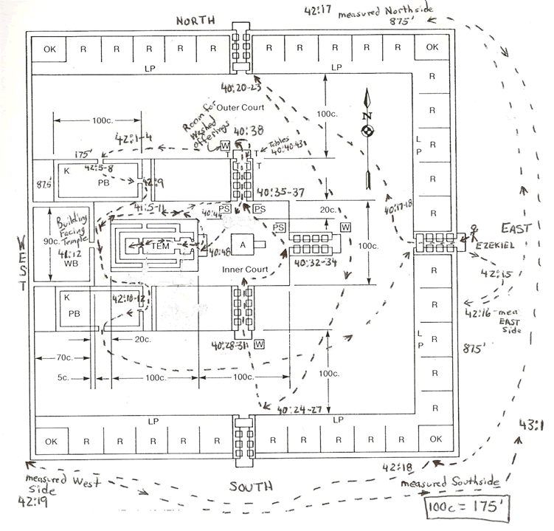

In Ezekiel 42-43 Ezekiel is escorted through the millennial temple by an angel. Above is the path Ezekiel walked through this new temple that is yet to be built.

