Daniel 5:1-31

605 BC Nebuchadnezzar begins to reign
604 Nebuchadnezzar has the dream of the statue in chapter 2
603 Nebuchadnezzar builds the golden image of chapter 3
586 BC Nebuchadnezzar burns Jerusalem
570 Nebuchadnezzar dreams of the great tree (Dan. 4:1-27)
569 Nebuchadnezzar is driven from his palace (Dan. 4:28-33)
562 Nebuchadnezzar is restored to throne (Daniel 4:34-37), he writes aniel chapter 4 and dies later that year
561 Nebuchadnezzar's son Evil Merodach begins to reign, he releases 55 year old Jehoiachin from prison; Daniel is 62
559 Neriglissar, a senior officer at Jerusalem's destruction, assassinates Evil Merodach
556 Nebuchadnezzar's daughter, Nitocris, is married to Nabonidus who becomes king of Babylon in 556 BC. They have a son named Belshazzar
554 Nabonidus moves to Harran to work on a temple to the moon god Sin and leaves Babylon to Belshazzar. Babylonians still worship Marduk like Nebuchadnezzar
555 Cyrus and Nabonidus make a treaty and conquer Southwest Asia
552 Nabonidus moves into Arabia; In the next ten years Babylon's inflation increases 50%, famine strikes the land. Nabonidus blames the people for rejecting the Moon god Sin
551 Daniel chapter 8, the vision of the goat and the ram
549 Cyrus and Darius unite.
547 Medes cross Tigris and overrun eastern Basbylon.
Elamites overrun southern Babylonia
546 Cyrus defeats Croesus of Lydia, Asia Minor
545 Nabonidus returns to Babylon to work on shrines and bring the gods of the cities into Babylon for protection
539 Nabonidus flees south 11 miles to Borsipppa
September - Cyrus defeats Babylon at Opis and Sippara with only the double wall of the city protecting Babylon
October 12 - Daniel chapter 5, Daniel is 84 years old
October 29, Cyrus enters Babylon and is welcomed as a gracious liberator.

5:1
Belshazzar is not recorded in history but in Daniel and sources that use Daniel like Josephus. Herodotus (400's BC) and Xenophon (300's BC) knew nothing of Belshazzar. If the book of Daniel had been written in the 200's then Nabonidus would be the last king and not Belshazzar. Multiple sources in archaeology have confirmed Belshazzar's existence and his position as king of Babylon along with his father.

"Great Banquet" - Persian kings recorded as entertaining 15,000, Alexander had 10,000 guests at a wedding, Xerxes had a large gathering from his empire for 180 days (6 months). Both Greek historians Herodotus and Xenophon write of this same party the night Babylon fell.

The date is October 12, 539 BC. According to the "Nabonidus Chronicle"

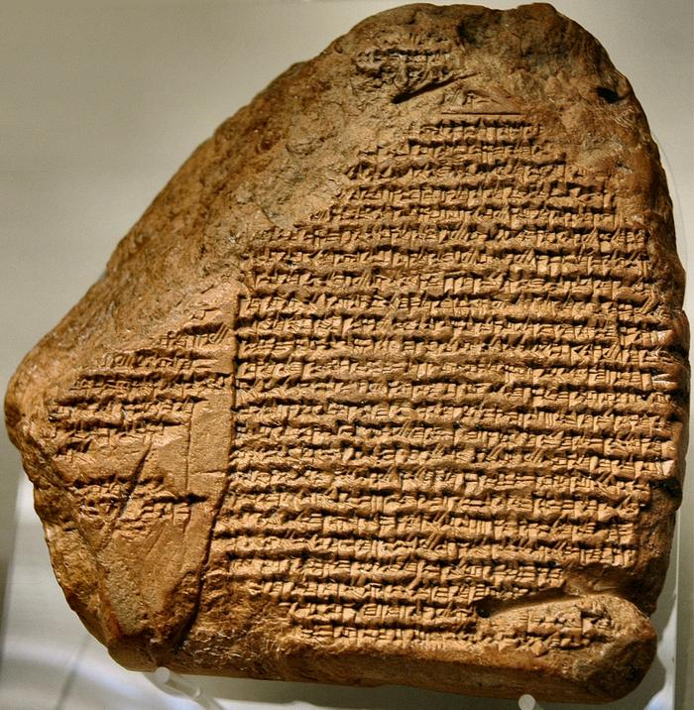
Nabonidus Chronicle that records the Babylonians had suffered a major defeat a few days before the party of October 12, 539 BC. One of the statements on this says, “The king was in Tema; the king’s son, courtiers and army were in Babylonia.”

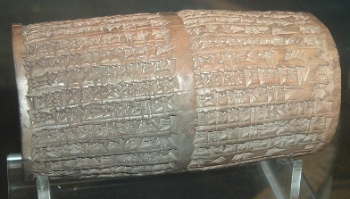
Nabonidus Cylinder says: “Belshazzar the firstborn son, the offspring of my heart.”

The reason for the feast appears to be an annual celebration that the Persians took advantage of and Belshezzar used to boost morale. The city was protected by water which gave them a vast supply. Heroditus says they had enough stored food to last for several years.
View of Babylon: http://www.maquettes-historiques.net/P103.html
More options: http://www.maquettes-historiques.net/P102.html

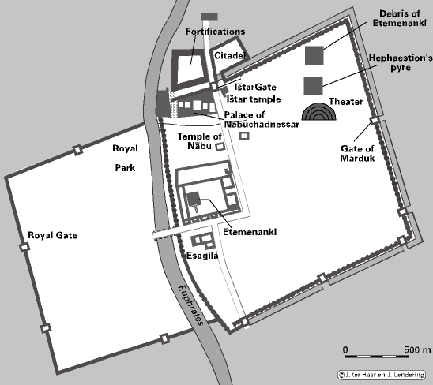

5:2
"He gave orders to bring the gold . . . .from the temple in Jerusalem" - this would have been taboo in this culture to violate holy things from another religion. Belshazzar was drunk.

5:3
The women were present and were being encouraged to drink

5:4
The holy vessels were used to toast the pagan gods. The king was showing his superiority over the gods and YHWH whom Babylon had conquered

Belshazzar may have been mocking:
A. Daniel's prophecy of Babylon's fall to Persia in 8:1-4 and 15-20
B. Isaiah prophecy of Cyrus' coming in Isaiah 44:28 and 45:1

5:5
"hand" is palm of the hand
The wall was "plaster" made of chalk or lime. Excavations of the throne room in 1899 revealed that the walls were washed over with white gypsum. This banquet room also appears to have been excavated and located.

5:25,26

Mene - Numbered - Belshazzar's evil life and rule would soon be over

Tekel - Weighed - "wanting" or "lacking, deficient" in moral worth

Parsin - Divided - his kingdom would be divided into pieces or destroyed, dissolved

Herodotus andXenophon tell us that the two sets of double walls extending for 17 miles and 40 feet high, but the water was diverted into a swamp and the soldiers waded through the river under the walls

Gobryas, Cyrus' commander, led soldiers into the palace where they found the king holding a dagger to kill himself. The king and attendants were overpowered and killed. Nabonidus was later captured and deported.

